DEPARTMENT OF COMPUTER STUDIES

## 

**(Applications Development and Emerging Technologies)**

**PRE-SUMMATIVE ASSESSMENT**

**1**

**PHP OUTPUT AND VARIABLE FAMILARIZATION**

|  |  |
| --- | --- |
| **Student Name / Group Name:** | Raine Angeline B. Zaldivar |
| **Members (if Group):** | |  |  | | --- | --- | | **Name** | **Role** | |  |  | |  |  | |  |  | |
| **Section:** | TW26 |
| **Professor:** | Mr. |

1. **PROGRAM OUTCOME/S (PO) ADDRESSED BY THE LABORATORY EXERCISE**

* Design, implement and evaluate computer-based systems or applications to meet desired needs and requirements.

1. **COURSE LEARNING OUTCOME/S (CLO) ADDRESSED BY THE LABORATORY EXERCISE**

* Understand and apply best practices and standards in the development of website.

1. **INTENDED LEARNING OUTCOME/S (ILO) OF THE LABORATORY EXERCISE**

At the end of this exercise, students must be able to:

* Familiarize various Web Architecture, tools that used in PHP
* The basic understanding before using PHP
* Familiarize in environment of web developing
* Use of comments, variables and Echo / Print

1. **BACKGROUND INFORMATION**

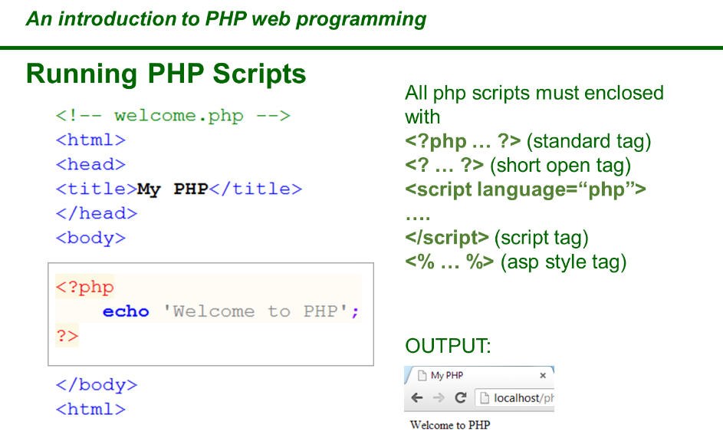

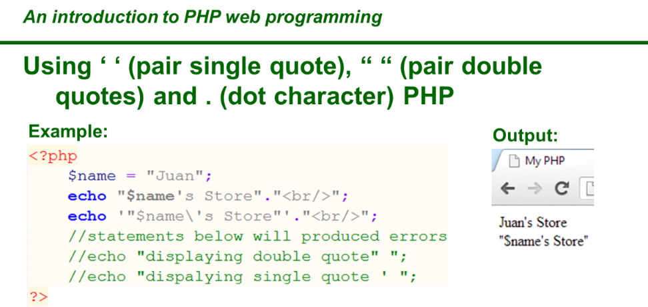

**Example**

Write some text to the output:

<?php  
echo "Hello world!";  
?>

**Definition and Usage**

The echo() function outputs one or more strings.

**Note:**The echo() function is not actually a function, so you are not required to use parentheses with it. However, if you want to pass more than one parameter to echo(), using parentheses will generate a parse error.

**Tip:** The echo() function is slightly faster than print().

**Tip:** The echo() function also has a shortcut syntax. Prior to PHP 5.4.0, this syntax only works with the short_open_tag configuration setting enabled.

Syntax

echo(*strings*)

Parameter Values

Parameter Description

strings Required. One or more strings to be sent to the output

Technical Details

Return Value: No value is returned

PHP Version: 4+

More Examples

Write the value of the string variable ($str) to the output:

<?php  
$str = "Hello world!";  
echo $str;  
?>

Join two string variables together:

<?php  
$str1="Hello world!";  
$str2="What a nice day!";  
echo $str1 . " " . $str2;  
?>

Write the value of an array to the output:

<?php  
$age=array("Peter"=>"35");  
echo "Peter is " . $age['Peter'] . " years old.";  
?>

Write some text to the output:

<?php  
echo "This text  
spans multiple  
lines.";  
?>

How to use multiple parameters:

<?php  
echo 'This ','string ','was ','made ','with multiple parameters.';  
?>

Difference of single and double quotes. Single quotes will print the variable name, not the value:

<?php  
$color = "red";  
echo "Roses are $color";  
echo "<br>";  
echo 'Roses are $color';  
?>

**PHP Variables**

**Creating (Declaring) PHP Variables**

In PHP, a variable starts with the $ sign, followed by the name of the variable:

**Example**

<?php  
$txt = "Hello world!";  
$x = 5;  
$y = 10.5;  
?>

After the execution of the statements above, the variable $txt will hold the value Hello world!, the variable $x will hold the value 5, and the variable $y will hold the value 10.5.

**Note:** When you assign a text value to a variable, put quotes around the value.

**Note:** Unlike other programming languages, PHP has no command for declaring a variable. It is created the moment you first assign a value to it.

Think of variables as containers for storing data.

**PHP Variables**

A variable can have a short name (like x and y) or a more descriptive name (age, carname, total_volume).

Rules for PHP variables:

* A variable starts with the $ sign, followed by the name of the variable
* A variable name must start with a letter or the underscore character
* A variable name cannot start with a number
* A variable name can only contain alpha-numeric characters and underscores (A-z, 0-9, and _ )
* Variable names are case-sensitive ($age and $AGE are two different variables)

Remember that PHP variable names are case-sensitive!

**Output Variables**

The PHP echo statement is often used to output data to the screen.

The following example will show how to output text and a variable:

**Example**

<?php  
$txt = "W3Schools.com";  
echo "I love $txt!";  
?>

The following example will output the sum of two variables:

**Example**

<?php  
$x = 5;  
$y = 4;  
echo $x + $y;  
?>

1. **GRADING SYSTEM / RUBRIC (please see separate sheet)**
2. **LABORATORY ACTIVITY**
3. The student will create their own portfolio using HTML and CSS with the integration of PHP Scripts
4. Refer to the samples below

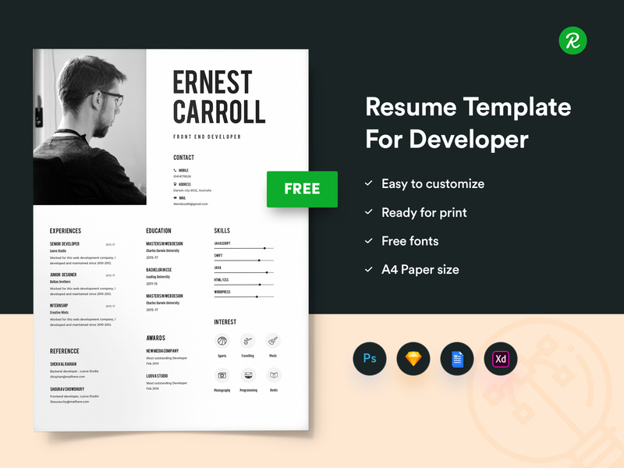



1. Use variable for the information provided in the webpage.

Example:

//variable for your firstname

$firstname = ‘Christopher’;

**VII. QUESTION AND ANSWER**

1. What program you use to create your webpage?
   * + - I used Visual Studio Code to create my webpage. I also ran it using XAMPP to support PHP locally on my computer
2. What kind of variables that you use in the webpage?
   * + - I used **string variables** for text like names, profession, and contact info. I also used an **array** to list skills and work experience. For example:

$firstname = "Raine Angeline";

$skills = ["Photoshop", "Event Photography"];

1. Is it important to study html and css before using PHP?
   * + - Yes, it’s really helpful! HTML and CSS are the foundation of how a webpage looks and is structured. PHP mostly controls the functionality or logic, so knowing HTML and CSS first makes it easier to understand where PHP fits in.
2. What are the different ways to produce an output in PHP?
   * + - The most common way is using echo to show text or values. You can also use:

print() – similar to echo

**VIII. REFERENCES**

1. <https://www.w3schools.com/php/func_string_echo.asp>
2. <https://www.w3schools.com/css/>
3. <https://www.w3schools.com/html/>
4. <https://www.w3schools.com/php/php_variables.asp>
5. <https://dribbble.com/shots/5295835-Free-Resume-Template-For-Developers-With-Portfolio>
6. <https://www.intelivate.com/career-strategy/simple-resume-model-career-portfolio-example>

***Snip and paste your source codes here. Snip it directly from the IDE so that colors of the codes are preserved for readability. Include additional pages if necessary.***

**<!DOCTYPE html>**

**<html lang="en">**

**<head>**

**<meta charset="UTF-8">**

**<title><?php echo "$firstname $lastname"; ?> - Portfolio</title>**

**<link rel="stylesheet" href="style.css">**

**<link href="https://cdnjs.cloudflare.com/ajax/libs/lightbox2/2.11.3/css/lightbox.min.css" rel="stylesheet" />**

**</head>**

**<body>**

**<?php**

**$firstname = 'Raine Angeline';**

**$lastname = 'Zaldivar';**

**$profession = 'Photographer';**

**$email = '202311025@example.com';**

**$phone = '+6394567890';**

**$bio = 'I am a passionate photographer with 2 years of experience capturing moments in events, portraits, and creative projects. I am an active member of "The Innovator" organization.';**

**$skills = ['Adobe Lightroom', 'Photoshop', 'Event Photography', 'Portraits', 'Photojournalism'];**

**$experience = [**

**['role' => 'Junior Photographer', 'company' => 'The Innovator', 'years' => '2025'],**

**['role' => 'Photojournalist', 'company' => 'Kuhaku Media', 'years' => '2023-Present']**

**];**

**$portfolio = ['photo1.jpg', 'photo2.jpg', 'photo3.jpg'];**

**?>**

**<div class="header-wrapper">**

**<div class="header">**

**<div class="header-left">**

**<h1><?php echo "$firstname $lastname"; ?></h1>**

**<p><?php echo $profession; ?></p>**

**</div>**

**</div>**

**<div class="profile-photo">**

**<img src="images/1x1.jpg" alt="Profile Photo">**

**</div>**

**</div>**

**<div class="section">**

**<h2>About Me</h2>**

**<p><?php echo $bio; ?></p>**

**</div>**

**<div class="section">**

**<h2>Contact</h2>**

**<p>Email: <?php echo $email; ?></p>**

**<p>Phone: <?php echo $phone; ?></p>**

**</div>**

**<div class="section">**

**<h2>Tools & Expertise</h2>**

**<div class="skills">**

**<?php foreach ($skills as $skill) {**

**echo "<span>$skill</span>";**

**} ?>**

**</div>**

**</div>**

**<div class="section">**

**<h2>Experience</h2>**

**<ul>**

**<?php foreach ($experience as $job) {**

**echo "<li><strong>{$job['role']}</strong> at {$job['company']} ({$job['years']})</li>";**

**} ?>**

**</ul>**

**</div>**

**<div class="section">**

**<h2>Portfolio</h2>**

**<div class="portfolio">**

**<?php foreach ($portfolio as $photo) {**

**echo "<a href='images/$photo' data-lightbox='portfolio'><img src='images/$photo' alt='Sample photo' class='thumb'></a>";**

**} ?>**

**</div>**

**</div>**

**<script src="https://cdnjs.cloudflare.com/ajax/libs/lightbox2/2.11.3/js/lightbox.min.js"></script>**

**</body>**

**</html>**

**CSS:  
* {**

**box-sizing: border-box;**

**margin: 0;**

**padding: 0;**

**}**

**body {**

**font-family: Arial, sans-serif;**

**background-color: #f4f4f4;**

**color: #333;**

**padding: 40px 20px;**

**max-width: 900px;**

**margin: auto;**

**line-height: 1.6;**

**}**

**.header-wrapper {**

**display: flex;**

**align-items: center;**

**justify-content: flex-start;**

**gap: 30px;**

**margin-bottom: 30px;**

**}**

**.header {**

**background-color: #222;**

**color: #fff;**

**padding: 30px 20px;**

**border-radius: 12px;**

**box-shadow: 0 4px 10px rgba(0,0,0,0.1);**

**flex: 1;**

**}**

**.header-left h1 {**

**font-size: 2.5em;**

**margin-bottom: 10px;**

**}**

**.header-left p {**

**font-size: 1.2em;**

**}**

**.profile-photo img {**

**width: 175px; /* Increased from 140px */**

**height: 175px; /* Increased from 140px */**

**object-fit: cover;**

**border-radius: 10%;**

**border: 4px solid #fff;**

**box-shadow: 0 4px 10px rgba(0,0,0,0.15);**

**}**

**.split-header {**

**display: flex;**

**align-items: center;**

**justify-content: space-between;**

**flex-wrap: wrap;**

**width: 50%;**

**}**

**.header-left {**

**flex: 1;**

**padding-right: 20px;**

**}**

**.header-right img {**

**width: 140px;**

**height: 140px;**

**object-fit: cover;**

**border-radius: 50%;**

**border: 4px solid #fff;**

**box-shadow: 0 4px 10px rgba(0,0,0,0.15);**

**}**

**h1 {**

**font-size: 2.5em;**

**margin-bottom: 10px;**

**}**

**h2 {**

**font-size: 1.5em;**

**margin-bottom: 10px;**

**color: #444;**

**border-bottom: 2px solid #eee;**

**padding-bottom: 5px;**

**}**

**.section {**

**margin: 30px 0;**

**background-color: #fff;**

**padding: 20px;**

**border-radius: 12px;**

**box-shadow: 0 2px 8px rgba(0,0,0,0.05);**

**}**

**.skills span {**

**display: inline-block;**

**background-color: #e0e0e0;**

**margin: 6px 8px 6px 0;**

**padding: 6px 14px;**

**border-radius: 20px;**

**font-size: 0.95em;**

**font-weight: bold;**

**}**

**ul {**

**padding-left: 20px;**

**}**

**p {**

**margin-bottom: 12px;**

**}**

**.portfolio {**

**display: flex;**

**flex-wrap: wrap;**

**gap: 15px;**

**justify-content: center;**

**}**

**.thumb {**

**width: 250px;**

**height: 180px;**

**object-fit: cover;**

**border-radius: 10px;**

**box-shadow: 0 2px 6px rgba(0,0,0,0.2);**

**cursor: pointer;**

**transition: transform 0.2s ease;**

**}**

**.thumb:hover {**

**transform: scale(1.05);**

**}**

**Note: The following rubrics/metrics will be used to grade students’ output.**

|  |  |  |  |  |
| --- | --- | --- | --- | --- |
| **Program (100 pts.)** | **(Excellent)** | **(Good)** | **(Fair)** | **(Poor)** |
| **Program execution (20pts)** | Program executes correctly with no syntax or runtime errors **(18-20pts)** | Program executes with less than 3 errors **(15-17pts)** | Program executes with more than 3 errors **(12-14pts)** | Program does not execute **(10-11pts)** |
| **Correct output**  **(20pts)** | Program displays correct output with no errors **(18-20pts)** | Output has minor errors **(15-17pts)** | Output has multiple errors **(12-14pts)** | Output is incorrect **(10-11pts)** |
| **Design of output**  **(10pts)** | Program displays more than expected **(10pts)** | Program displays minimally expected output **(8-9pts)** | Program does not display the required output (**6-7pts)** | Output is poorly designed **(5pts)** |
| **Design of logic**  **(20pts)** | Program is logically well designed **(18-20pts)** | Program has slight logic errors that do no significantly affect the results **(15-17pts)** | Program has significant logic errors **(3-5pts)** | Program is incorrect **(10-11pts)** |
| **Standards**  **(20pts)** | Program code is stylistically well designed **(18-20pts)** | Few inappropriate design choices (i.e. poor variable names, improper indentation) **(15-17pts)** | Several inappropriate design choices (i.e. poor variable names, improper indentation) **(12-14pts)** | Program is poorly written **(10-11pts)** |
| **Delivery**  **(10pts)** | The program was delivered on time. **(10pts)** | The program was delivered a day after the deadline. **(8-9pts)** | The program was delivered two days after the deadline. **(6-7pts)** | The program was delivered more than two days after the deadline. **(5pts)** |